CONGLETON GRIZZLIES
BASKETBALL CLUB

WELCOME PACK

Updated September 2022




Dear Parents/Guardians,

Welcome to our club!

In this guide you will find information on:

- Club history & introduction.
- Training and playing information.
- Executive Committee
- Club policies
- Safeguarding and Welfare
- Membership
- Communication
- Contacts

HISTORY & INTRODUCTION

Congleton Grizzlies Basketball Club has been running since the early 70's, with William Baxter being the figurehead of the club. The club had a senior men’s team that participated in the MABL leagues throughout the 1980's, winning the division 1 title in 1989. Maintaining progress as a community based club, the Grizzlies started to decline in the early 2010's due to lack of funding and membership, leading up to the club almost being dissolved. As we all know, COVID-19 hit hard in 2020, and the club was severely affected. Lack of investment, club staff and participation led to a significant rebrand under the stewardship of some young, passionate coaches. With this rebrand came a renewed push to make the Grizzlies a dominant force once again, and the new Executive Committee have been successful thus far. In the 6 months post-lockdown, membership rose to 148 members for the season. This led to re-entry into men's competitive leagues. The junior programs soon followed, with a large number of members meaning the club expanded to multiple venues and entering two teams into competitive leagues for 2022-23. In such a short time since the rebrand, Congleton Grizzlies have become a large community club in the heart of the town, with the name being recognised once again as a premiere basketball club in the North West. We hope that you will become a part of the clubs history, believing in the clubs ethos and values and pushing forward to really make the club one Congleton can be proud of.
The club is affiliated to the national governing body, Basketball England. For more information, visit the Basketball England website at www.basketballengland.co.uk .

TRAINING & GAMES

Training for the club usually takes place:

CHS Sports Centre | Eaton Bank Academy
Mondays  U14s, u16s - 7pm until 8pm  U18, Senior Men’s - 8pm until 10pm  Tuesdays  16+ women’s - 7.30pm until 8.30pm  Fridays  U14s Team Training* - 7pm until 8pm  U16s Team Training - 8pm until 9pm  *u14s Red/Black teams will both share a court at this session, however will be split into their relevant teams. | Mondays  U10s, u12s - 7pm until 8pm
 | Congleton Leisure Centre

Home games usually take place:
- The season starts in September, and finishes around April.
- Our home games take place on Saturdays from 12pm until 6pm, based at CHS Sports Centre. In case of venue issues, games will move to the local leisure centre. Any changes will be communicated in due course.

NOTE: Personal transport is used to travel to away games due to rising costs of minibus hire. The club has procedures in place to streamline this process and ensure the safety of all involved when travelling.

EXECUTIVE COMMITTEE

The below listed persons are elected officials of voting members of the club. Voting members are listed club volunteers and any registered senior member not in arrears with the club at the time of voting. These positions are re-elected each season at the clubs Annual General Meeting as outlined in the club constitution. The five roles listed are the only official controlling roles at the club.
Listed persons are correct as of September 2023.

Club Chairman: Jack Purdham
Club Secretary: William Baxter
Treasurer: Ryan Anderson
Club Head Coach: Ryan Anderson
Club Liaison: Wayne Hartshorn

Other roles
Club Welfare Officer: William Baxter
Social Media Manager: Ryan Anderson
Youth Coach: Tom Watson, Matthew Akker, William Baxter, Lewis Brisco, David Leah, Leam Wright
Seniors Coach: Ryan Anderson, Jack Purdham

CLUB POLICIES

We firmly believe that every person has the right to be safe in sport and we have policies to set out how everyone should behave. We have adopted all of Basketball England’s policies which include Safeguarding, Equality and Equity Policy and Code of Ethics and Conduct.

All members are expected to:
- Play fairly by the rules of the game and the club.
- Listen to the coaches.
- Respect other members of the club and other participants.

All members and their parents can expect:

- A friendly, welcoming, family-orientated atmosphere.
- To be able to participate in the club, including social activities.

Further information and documentation can be found on our website under the 'Important Information' section. This includes links to all club documents including, but not limited to: Coaches Code of Conduct, Spectators Policy, Club Constitution, Social Media Policy and Duty of Care.

SAFEGUARDING & WELFARE
Congleton Grizzlies Basketball Club has a dedicated Club Welfare Officer to help create a safe and welcoming environment for our members, coaches and parents. If you have any questions relating to welfare/safeguarding or would like to raise a concern, our CWO is your main point of contact.
Our CWO helps to protect our young members against abuse of any kind. They also support the education of our coaches, volunteers and committee members on good practice, processes & procedures and what to do if they have concerns about a young person’s safety.
Our CWO also assists Basketball England if there are any investigations/concerns raised against the club. This involves:
- Being a point of contact between the club and NGB for when concerns are raised against the club.
- Being able to collate evidence/information regarding concerns.
- Being able to collect statements/witness accounts of any concern.
- Being able to compile any evidence in a suitable manner that can be submitted to Basketball England.

Club Welfare Officer Contact Details: William Baxter

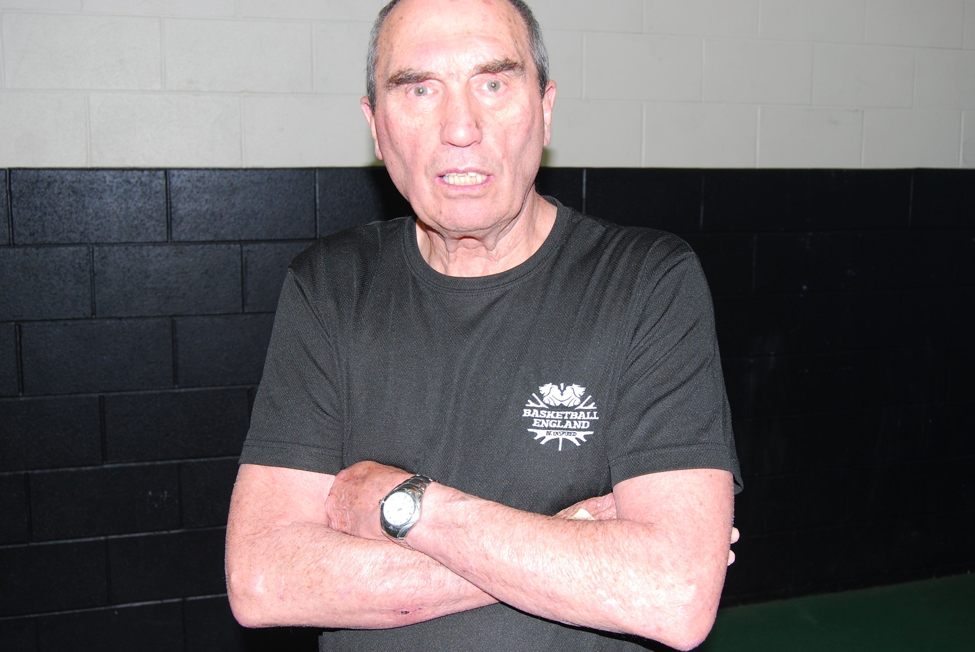
Photo of Club Welfare Officer

POLICY FOR LATE COLLECTION

Congleton Grizzlies Basketball Club has a late collection procedure as outlined below.

For training sessions:
- Each training session is allocated to a registered club coach. This coach is wholly responsible for the safety and wellbeing of all members and participants under his care throughout the session. The session includes the 10 minutes prior to session start, and until the last participant has departed the venue.

For fixtures:
- Each team will be allocated a closed group on a downloadable app called Teamer. This app has a built in 'messages' feature in which to contact the coach. All fixtures will go through the Teamer app.
- As an option, the parents can (with permission from the team coach) create a private messaging group to aid with organisation of fixtures and travel. NOTE: By joining these groups, you consent to provide your personal information to another member/parent at the club. This is not regulated by the club, and as such the club holds no liability or responsibility for this data.

In cases of late collection, staff will:

- attempt to contact the parents on their contact numbers;
- use the alternative contact name/number if possible;
- wait with the child at the sport facility, with other staff or parents present if possible;
- if the child is not collected within 30 minutes of the end of the session, the staff member should speak to the Club Welfare Officer to decide whether it is necessary to contact Children’s Social Care, for example, where the staff member has not been able to make contact with a parent/guardian;
- Remind parents of the policy relating to late collection.

In cases of late collection, staff will not:

- take the child home or to any other location without speaking to their parents;
- send the child home with another person without permission from a parent;
- leave the child on their own;
- ask the child to wait in a vehicle or sport facility with you alone.

MEMBERSHIP

The club is open to all. You need to register as a member of the club before you start to train regularly or play in any games. You may also need to purchase some items of kit.

- Details of annual membership fee
The annual membership fee for the season 2023-24 is £25. This is a one-off fee that covers from September 1st 2023 until July 31st 2024, at which point club membership expires. This fee is payable via an online invoice that is emailed to the newly registered player upon completion of the membership form. The membership form can be found on the club website under the membership tab.
Details of any additional session/match fees
Sessions fees are subject to change. The current session fees are age based. Junior players (those under 16) are £4.50 per session, payable prior to arrival using our online booking system. Seniors session fees are £9 per session, payable prior to arrival using our online booking system. There are monthly packages available to senior members to reduce the monthly cost overall if they are regular attendees. These can be found on GymCatch.
Match fees for the season 2023-24 are £6 per person, payable prior to arrival using our online booking system. For fixtures, mobile card readers will be available to pay for the fixture, however an increased fee of £8 will be in effect to cover expenses per transaction.
- Payment details
Congleton Grizzlies Basketball Club use an online booking system to manage payments and multiple venues. The booking system is hosted via a downloadable app called GymCatch. This app is free to download, and upon downloading the user will be required to create an account and provide a payment method. Upon completion of these requests, the user should then search for 'Congleton Grizzlies' and use the calendar to 'book in' to the session. Payment will be taken at this point, and an email receipt will be sent to the user.
Mobile card readers may also available for use at the venues, however these carry an increased fee for paying on arrival. Please speak to the leading coach of the session to enquire about this form of payment.
Please speak to the Club Secretary for more details on the paperwork which needs to be read, signed and returned.

It is also free to sign up to be a member of Basketball England. Basketball England membership gives you a range of benefits and up to date information about what is happening within the sport.

COMMUNICATION

Congleton Grizzlies Basketball Club will use the following procedures/platforms to communicate with you and your child/children.

The club operates the following social media platforms:
- Facebook
- Instagram
- Twitter
- TikTok
- Twitch
- WhatsApp

The first point of contact for the club is the email address (congletongrizzlies@gmail.com). All members of the Executive Committee have access to this email address. If you are unable to email your query, please use WhatsApp, Facebook and Instagram as your next port of call. These accounts are operated by the named Social Media Managers above. Twitter, TikTok and Twitch are not used currently, and are only owned by the club due to naming rights and copyright purposes.

We look forward to welcoming you to Congleton Grizzlies Basketball Club.

LET’S GO GRIZZLIES!

Yours Sincerely,

Ryan Anderson

Club Treasurer and Head Coach

GENERAL DATA PROTECTION REGULATIONS 2018

Congleton Grizzlies Basketball Club is a privacy conscious organisation and is strongly committed to privacy. Our Data Protection Policy, follows guidelines set out in General Data Protection Regulations (May 2018).

The above act was introduced to unify all EU member states' approaches to data regulation, ensuring all data protection laws are applied identically in every country within the EU. The GDPR was created to regulate how businesses use data, ensuring it's the same across the entire EU. It has been adopted into UK law from 25th May 2018, and we now abide by UKGDPR.

It is our responsibility to ensure that the documentation and data held on subject is:

- Processed lawfully, fairly and in a transparent manner
- Collected for specified, explicit and legitimate purposes
- Adequate, relevant, and limited to what is necessary
- Accurate and kept up to date, where necessary
- Kept in a form which permits identification of data subjects for no longer than is necessary
- Processed in a manner that ensures appropriate security of the personal data

Any data held shall be processed fairly and lawfully and in accordance with the rights of data subjects under the regulation. We have a legitimate business interest in collecting this personal data so that we can effectively run and administer the club. The data subjects will have the right, upon written request, to be told what personal data about them is being processed. They will also have the right to be informed of the source of the data and to whom it may be disclosed.

The data collected on this form will be used solely for use by Congleton Grizzlies Basketball Club during the season that this information has been collected for, where your son/daughter is participating and the data will not be shared with any 3rd party without prior consent.

If you have queries regarding data protection, please contact the Club Secretary.

